|  |  |
| --- | --- |
| LIFE logo | **HOLY CROSS COLLEGE**  **SEMESTER 1, 2016**  **Question/Answer Booklet** |

Please place your student identification label in this box

11 PHYSICS

Student Name ___________________________________

Student’s Teacher __________________________________________

#### Time allowed for this paper

Reading time before commencing work: 10 minutes

Working time for paper: 3 hours

**Materials required/recommended for this paper**

To be provided by the supervisor

This Question/Answer Booklet

Multiple-choice Answer Sheet

Data Sheet

***To be provided by the candidate***

Standard items: pens, pencils, eraser, correction fluid, ruler, highlighters

Special items: non-programmable calculators satisfying the conditions set by the School Curriculum and Standards Authority for this course

**Important note to candidates**

No other items may be taken into the examination room. It is **your** responsibility to ensure that you do not have any unauthorised notes or other items of a non‑personal nature in the examination room. If you have any unauthorised material with you, hand it to the supervisor **before** reading any further.

**Structure of this paper**

|  |  |  |  |  |  |
| --- | --- | --- | --- | --- | --- |
| Section | Number of questions available | Number of questions to be answered | Suggested working time  (minutes) | Marks available | Percentage of exam |
| Section One:  Short Answers | 15 | 15 | 60 | 65 | 40 |
| Section Two:  Problem-solving | 6 | 6 | 90 | 77 | 48 |
| Section Three:  Comprehension | 1 | 1 | 30 | 20 | 12 |
|  | | | | 162 | 100 |

**Instructions to candidates**

1. The rules for the conduct of examinations at Holy Cross College are detailed in the College Examination Policy*.* Sitting this examination implies that you agree to abide by these rules.

2. Write your answers in this Question/Answer Booklet.

3. Working or reasoning should be clearly shown when calculating or estimating answers.

4. You must be careful to confine your responses to the specific questions asked and to follow any instructions that are specific to a particular question.

5. Spare pages are included at the end of this booklet. They can be used for planning your

responses and/or as additional space if required to continue an answer.

• Planning: If you use the spare pages for planning, indicate this clearly at the top of the

page.

• Continuing an answer: If you need to use the space to continue an answer, indicate in

the original answer space where the answer is continued, i.e. give the page number.

Fill in the number of the question(s) that you are continuing to answer at the top of the

page.

6. Answers to questions involving calculations should be ***evaluated and given in decimal***

***form*.** It is suggested that you quote all answers to ***three significant figures***, with the

exception of questions for which estimates are required. Despite an incorrect final result,

credit may be obtained for method and working, providing these are ***clearly and legibly set***

***out***.

7. Questions containing the instruction *"****estimate****"* may give insufficient numerical data for their

solution. Students should provide appropriate figures to enable an approximate solution to

be obtained. Give final answers to a maximum of ***two significant figures*** and include appropriate units where applicable.

8. Note that when an answer is a vector quantity, it must be given with magnitude and direction.

9. In all calculations, units must be consistent throughout your working.**SECTION ONE: Short Answers**

**Marks Allotted: 65 marks out of 162 total.**

Attempt ALL 15 questions in this section. Answers are to be written in the space below or next to each question.

1. In terms of the energy of particles, explain why a sample of a volatile liquid, such as methylated spirits or acetone, cools as the liquid evaporates? **(4 marks)**

2. Jane has been asked to give a short talk on sea breezes. Listed below are some key parts of her speech. Help her prepare the speech by choosing the best alternative for the options given.

In the following, indicate the answer by circling the best choice from the bolded options.

**(4 marks)**

*“During hot summer days***, [radiant/convective]** *energy from the sun heats the land and sea. The land, however, has a* **[lower/higher]** *specific heat capacity than the sea and soon has a* **[higher/lower]** *temperature than the water. The air near the ground becomes hot as a result of* **[convection/conduction]***. As the air gets hot, it* **[contracts/expands]**, *becoming* **[less/more]** *dense than the air over the sea. The air over the* **[land/sea]** *rushes in towards the***[sea/ land]**, *replacing the rising warm air, causing what is know as a sea breeze.”*

3. A student wishes to cool her 375 g soft drink (specific heat 3.50 x 103 Jkg-1K-1) from an initial temperature of 30.0 °C to a more pleasant 5.00 °C. What mass of ice at 0.00 °C should she add? **(4 marks)**

4. During a Myth Buster's programme investigating ballistics, a 1.75 g bullet is analysed by a high-speed video. It enters a pine board at a speed of 2.90 x 102 ms-1 and emerges out of the other side at 1.10 x 102 ms-1. Calculate the work done by the board on the bullet.

**(4 marks)**

5. A golf ball of mass 45.0 g is dropped onto concrete, striking it at 6.35 ms-1 and rebounding at

4.60 ms-1. Calculate the ball's change in momentum. **(4 marks)**

6. In playgrounds at McDonald and Hungry Jack's stores in Australia, recycled tyre rubber is used to cover the ground around and underneath the play equipment. Using sound Physics principles, explain why this is seen as a very good safety procedure. **(3 marks)**

7. A student was asked to measure the diameter of a spherical steel ball in order to calculate its volume for a density calculation. She recorded the measurement as 1.2 ± 0.2 cm.

(a) Express the uncertainty as a ***percentage uncertainty***. **(2 marks)**

(b) Determine the volume of the steel sphere (V = 4/3 πr3), expressing the answer with the appropriate significant figures and absolute error. **(4 marks)**

8. During an Olympic power-lifting event, Ryan manages to snatch 140.0 kg from the floor to 2.10 m above the floor (and over his head) in a total time of 1.80 s. Determine the average power generated by Ryan during this lift. **(3 marks)**

Weightlifting

9. (a) Just before she serves a ball in a tennis match, Serena Williams throws the ball towards the ground with an initial velocity of 5.00 ms-1. If she releases the ball 0.800 m above the ground, with what velocity does it hit the ground? **(3 marks)**

(b) If the ball has a mass of 57.0 g, how much energy does it have as it hits the ground?

**(3 marks)**

10. (a) Explain why heat transfer by conduction is more effective in liquids than in gases. **(2 marks)**

(b) Explain why aluminium is a better conductor of heat than phosphorus, despite the fact that both are solids at room temperature and they have similar atomic masses.

**(2 marks)**

11. Solar water heaters are popular in Perth. The intensity of the sun is approximately

8.00 x 102 Wm-2 and a typical heater would have an area of about 2.00 m2. If the water was not circulating, calculate the temperature increase in 30.0 minutes if the mass of water in the pipes in the panel is 15.0 kg. **(4 marks)**

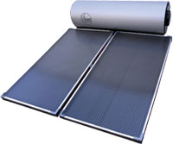

12. A cricket ball moving at 1.40 x 102 kmh-1 south is struck by a batter and moves due west just after impact at 1.80 x 102 kmh-1. Ignoring any frictional resistances, calculate the change in velocity of the ball. **(6 marks)**

13. Two bumper cars in an amusement park collide head-on. One has a mass of 4.50 x 102 kg and is moving at 4.50 ms-1, while the other has a mass of 5.50 x 102 kg and is moving at

3.70 ms-1. If the heavier vehicle rebounds at 0.500 ms-1, calculate the final velocity of the lighter vehicle. **(5 marks)**

14. A plane flying due east from Perth at 9.50 x 102 kmh-1 has to contend with a wind of

1.30 x 102 kmh-1 heading northeast. Determine its resultant velocity (***in kmh-1***) over the ground. **(5 marks)**

15. A force is applied to an object over a short period of time as shown in the graph below. Use the graph to determine the impulse acting on the object. **(3 marks)**

F (N)

3.0

0.05

0.10

0.15

t (s)

**THIS PAGE HAS BEEN DELIBERATELY LEFT BLANK.**

**SECTION TWO: Problem Solving**

**Marks allotted: 77 marks out of 162 marks total.**

Attempt ALL 6 questions in this section. The marks allocated to each question are given and the answers should be written in the spaces provided.

**(12 marks)**

16. The motion of an object is represented in the graph below.

Velocity Graph

(a) Determine the total displacement of the object. **(5 marks)**

(b) Draw an acceleration – time graph of this motion, giving ***clear scales*** on each axis.

**(7 marks)**



**(12 marks)**

17. “The Boomerang” is a roller coaster ride at Knott’s Berry Farm amusement park in Los Angeles. Part of the ride is as shown below with a 4.32 x 103 kg coaster moving at 4.00 ms-1 at point A.

Rollercoaster

(a) Calculate the total energy of the roller coaster at point A. **(3 marks)**

(b) How fast is the coaster travelling at point B? **(3 marks)**

(c) Theoretically, the minimum speed required to safely make it through point C is

10.3 ms-1. Assuming that the designers of the ride have built in a “safety margin”, determine:

(i) the speed at point C. **(4 marks)**

(ii) the safety margin built in, expressing the answer as a percentage. **(2 marks)**

**(12 marks)**

18. In a laboratory investigation, a group of students applied forces of differing sizes onto an object. Each force was applied for a time of 1.20 s. The students measured the change in velocity of the object for each trial. The results are given below.

|  |  |
| --- | --- |
| **Force**  **(N)** | **Change in Velocity (ms-1)** |
| 0 | 0 |
| 1.6 | 1.8 |
| 3.1 | 3.5 |
| 4.9 | 5.8 |
| 7.8 | 8.9 |
| 11.3 | 13.0 |
| 15.4 | 17.5 |

(a) Graph these results on the graph paper provided. Draw the line of best fit.

(HINT: Graph "change in velocity" on the x-axis.) **(4 marks)**

(b) Calculate the gradient of the line of best fit. **(4 marks)**

(c) Use the gradient to determine the mass of the object. **(4 marks)**

prac exam youngs mod 10 by 10

**(14 marks)**

19. In an experiment to determine the latent heat of ice, a student used the apparatus below.

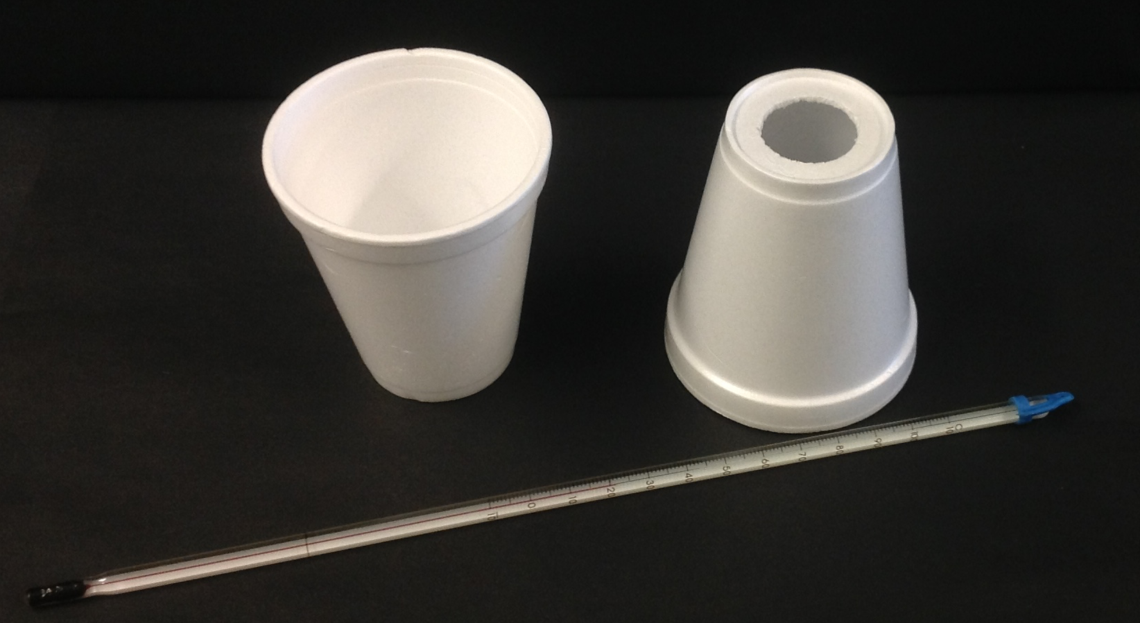 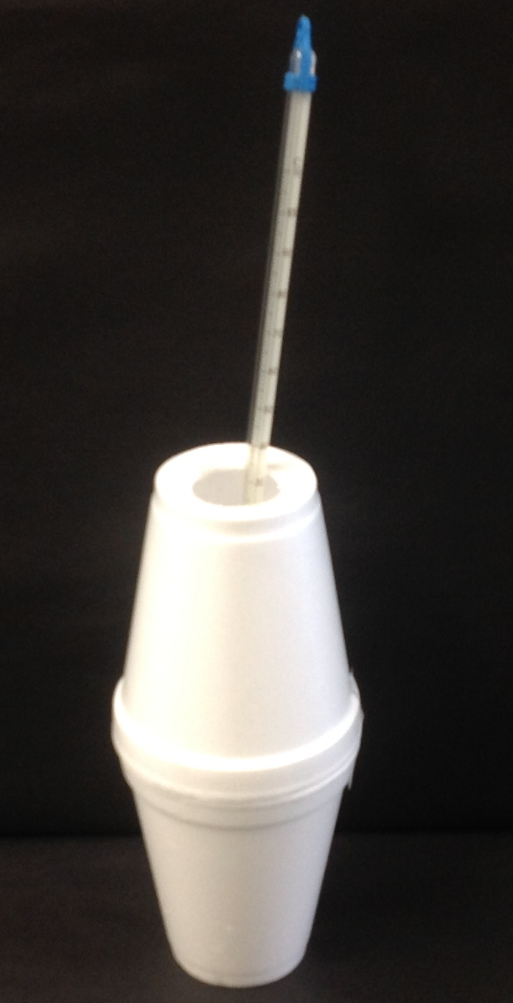

Ice, that was previously dried with a tissue, was added to the water in the polystyrene cup until a significant temperature drop was recorded. The mass of the cup was then reweighed. The liquid was stirred continuously.

(a) (i) Why was polystyrene a good choice to use as a receptacle? **(1 mark)**

(ii) Why was the mass of ice not measured by first weighing it and then adding to the insulated beaker? **(1 mark)**

(iii) Why did the student dry the ice with a tissue before adding it to the water?

**(1 mark)**

(b) If room temperature was 25.0 °C, why was starting the experiment at 40.0 °C and

concluding at approximately 10.0 °C a good experimental technique? **(2 marks)**

The student tabulated the following results:

|  |  |
| --- | --- |
| Mass of water before adding the ice (g) | 100.0 |
| Mass of water after adding ice (g) | 135.0 |
| Initial temperature (0C) | 40.0 |
| Final temperature after adding the ice (0C) | 10.0 |
| Mass of ice (g) |  |

(c) Using the student's data, calculate the latent heat of ice. **(6 marks)**

(d) Determine the percentage error between your value and the accepted value of

3.34 x 105 Jkg-1 and comment on the accuracy and techniques the student used.

**(3 marks)**

**(20 marks)**

20. A 0.120 kg rocket accelerates rapidly from rest up to a height of 1.30 x 102 m where the “motor” cuts out. Its speed is 80.0 ms-1 at this point. After this point, the rocket continues to rise under the influence of gravity to a maximum height before falling back to earth. No parachute or streamer is deployed to slow its decent.

Rocket problem

(a) Calculate the maximum height reached by the rocket.

(Hint: Consider the movement from the point where the rocket motor stops).

**(6 marks)**

(b) Theoretically, how long is the rocket in flight from the point where the motor stops?

**(4 marks)**

(c) Theoretically, what is the impact velocity with the ground? **(3 marks)**

(d) Explain why your answer to part (c) is “theoretical” rather than “real”. **(2 marks)**

(e) Draw a displacement-time graph for the motion of the rocket after the rocket motor stops. Include ***clear scales*** on each axis. (Take t = 0 when the rocket motor stops.)

**(5 marks)**



**(7 marks)**

21. A 70.0 kg person is in a lift that is stationary at the thirtieth floor of a building. The lift uniformly accelerates downwards at 1.75 ms-2 for 3.00 s before maintaining its speed. As it nears the ground floor, the lift decelerates uniformly at 2.00 ms-2 to bring the lift to a stop.

(a) What is the apparent weight of the person as the lift starts to move down from the thirtieth floor? **(4 marks)**

(b) Determine the apparent weight when the lift is moving downwards with a constant speed. **(3 marks)**

**SECTION C: Comprehension and Interpretation**

**Marks Allotted: 20 marks out of 162 marks total.**

Read the passage carefully and answer all of the questions at the end. Candidates are reminded of the need for correct English and clear and concise presentation of answers. Diagrams (sketches), equations and/or numerical results should be included where appropriate.

Pole vaulting can be seen as a series of stages.

**• Run up** - pole carried horizontally.

• **Going up** - pole flexed.

• **Top** - body over bar, pole straight.

• **Coming down** - pole falling away.

• **Landing** on large cushioned landing pad - pressed down by body.

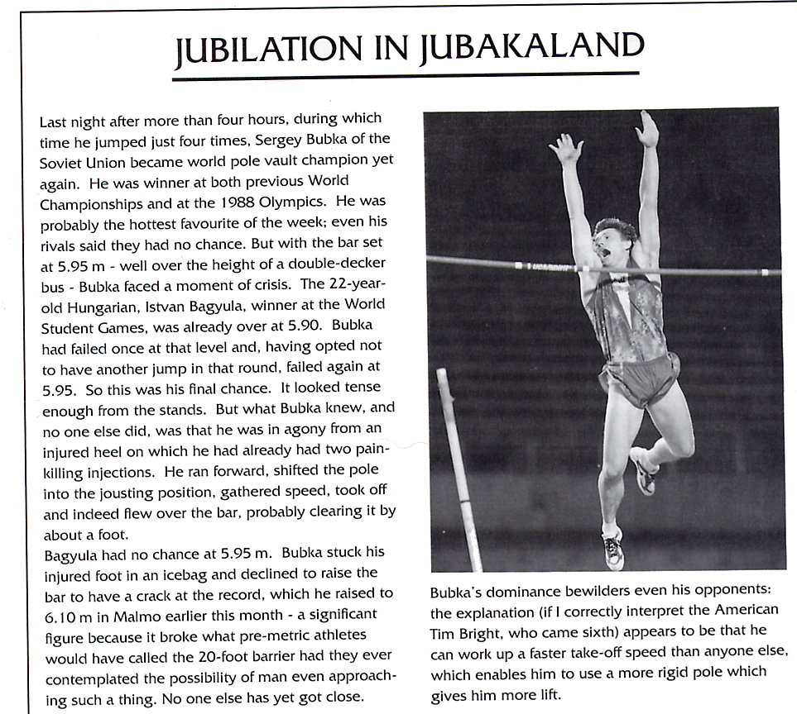

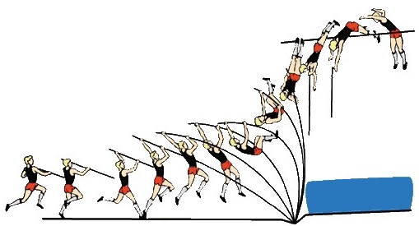

22. (a) Describe the energy changes that are occurring during each stage of the pole vault.

**(5 marks)**

(b) Sketch a graph to illustrate how the pole-vaulter's potential energy changes with time

during the pole vault. Mark on the position of the pole-vaulter at significant points.

**(3 marks)**

**Energy**

**time**

(c) On the same graph, show how the pole-vaulter's kinetic energy changes with time.

**(2 marks)**

(d) ***Estimate*** the maximum potential energy that Bubka gains during the world record vault. **(3 marks)**

(e) (i) Do you think his maximum kinetic energy would be greater or less than this?

**(1 mark)**

(ii) Explain your answer, considering conservation of energy. **(2 marks)**

(f) In the article, the comment is made that the champion pole-vaulter achieves a much faster take-off speed than his rivals and this means that he can use a much stiffer pole.

(i) How does the faster take-off speed help? **(2 marks)**

(ii) Why do you think using a stiffer pole is an advantage? **(2 marks)**

**END OF EXAMINATIONTHIS PAGE HAS BEEN DELIBERATELY LEFT BLANK.**

**THIS PAGE HAS BEEN DELIBERATELY LEFT BLANK.**

**THIS PAGE HAS BEEN DELIBERATELY LEFT BLANK.**

**THIS PAGE HAS BEEN DELIBERATELY LEFT BLANK.**